EMBODIMENT TOOLS for Kids Yoga & Mindfulness Teachers: Grounded Sensitivity as a Living Foundation

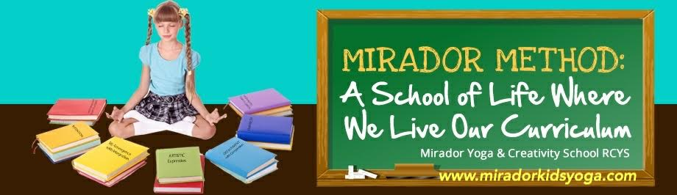
Today we are addressing our Primary Wound and the deep healing that naturally occurs when we understand the power of intimacy with our inner Being, our Essence. Our Primary Wound in the western world is the split and separation between our Thinking (our north pole…male energy…sky…mind space) and our Being (south pole…female energy…Earth…Being). We were raised in this western culture, so we have all carried this primary wound within us accepting it as a given of our human nature. Take a look around you at a world which has been using the Inner Masculine eyes displaying a sense of disconnection, anxiety and the obsession with self and an illusory pursuit of happiness. There is no happiness in separation. And it has never been.
We are persuaded to separate from the body and live in the head. Disconnected from the body’s intelligence, we also disconnect from the wholeness of the present moment.
In our workshop, we are going to experience the simplicity and depth of this dance between head, heart and belly brains…and how it shows up in all we thin, plan and do.
We begin with a gentle exploration of these three poles of existence…so here we are.
We are born with Three Brains:
1. First Brain is the one in our head. This is where we consciously think. It is by nature exclusive and it excels at analysis, abstraction, known relationship, control, and systemization.
2. Second Brain is the one in our belly (this is where we can consciously be. It is by nature inclusive and it excels at Integration, Felt relationship, Harmony and Presence.
3. Third Brain is one in the heart (and this is where our wholeness meets the world's wholeness.)
All three brains are complementary and designed to work together. Unlike most cultures, our western culture has been committed to the strengths of the first brain (the topdown approach to life) which has thrown our culture off balance, has brought along a plethora of mental imbalances reinforcing the sense of isolation (a divided inner state of being) and making us feel incapable of moving into wholeness as a state of “inner nourishment” which is our divine birthright.
But what limits our sensitivity to wholeness is always found in the body. Watch how the body and the world are in a dance between these opposites (the center of awareness in the head…first brain) and (the center of awareness and feeling sensations in the pelvic bowl…second brain) and the heart space (center of emotions…third brain). When we bounce between the male and female poles (the head and the belly brain), we start to experience our consciousness in a new way. We can go from being in the mind only (first brain in the head) to feeling our thinking in the belly (second brain intelligence) and then our heart space expands (third brain surrender) into embracing harmony in every moment.
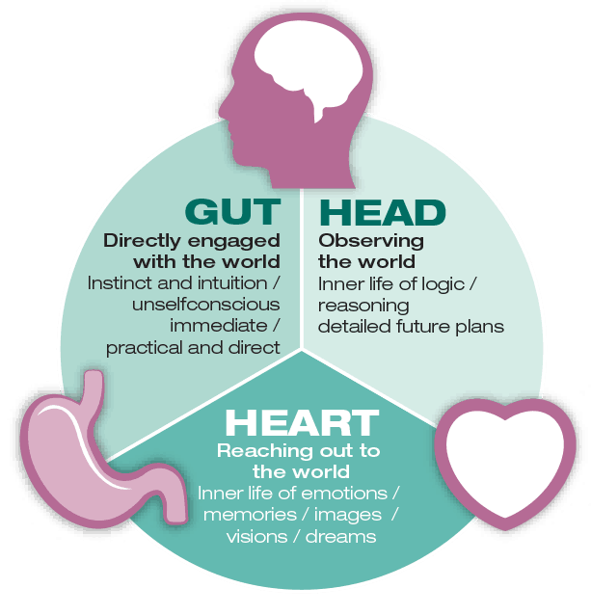

And when we do this for ourselves, we are actually re-writing the story of our whole culture.
We are finally coming HOME.
=======================================================================
In Philip Shepherd’s book ‘Radical Wholeness’, we read and contemplate on this reality:
“Rather than ‘feel-feel-at flesh-inside’, we are teaching ‘think-think-at-head-inside’. Our culture places so much value on what the head knows and so little on what the body knows, we tend to either downplay or pre-organize what we are feeling. We judge, calculate, modify, anticipate and strategize in response to what is happening around us; and we may barely notice the discomfort created by our fevered obsession to know what is happening in the abstract (the mind territory) without feeling what is actually happening in the Present. What sustains that obsession is a fear over what we might lose if we allowed our awareness to come to rest in our body and attune to the Present.”
The Book “New Self, New World: Recovering Our Senses in the 21st Century” by Philip Shepherd
((A wake-up call for a more female oriented culture where peace, gentleness, sensitivity, harmony, creativity, and body genius prevail.))
This book challenges the primary story of what it means to be human, the random and materialistic lifestyle that Philip calls our “shattered reality.” This reality encourages us to live in our heads, self-absorbed in our own anxieties. Drawing on diverse sources and inspiration, New Self, New World reveals that our state of head-consciousness falsely teaches us to see the body as something we possess and to try to take care of it without ever really learning how to inhabit it. Philip articulates his vision of a world in which each of us enjoys a direct, unmediated experience of being alive. He petitions against the futile pursuit of the “known self” and instead reveals the simple grace of just being present. In compelling prose, the author asks us to surrender to the reality of “what is” that enables us to reunite with our own being.”

This is where the practice/coaching tool of “grounded sensitivity” comes in for me. When I personally first heard Philip mention this concept in a weeklong radical wholeness retreat here at the Lotus Heart Centre in Ontario (back in October 2019), I immediately knew we have touched upon something so profound and yet so simple.
Grounded Sensitivity is a living Foundation. We are all born with unique clusters of sensitivities and we often sense that life is not safe, so we feel vulnerable and displaced. But we can now learn to re-sensitize our bodies through simple embodiment & grounding exercises to access a state of inner stability and deepest security.
Intimate companionship with life is always present...right here. There is a deeply nourishing realm of Being in the body awaiting to be discovered. We have no aliveness in this “body” until we actually feel it.
The world longs for us to re-sensitize our bodies and then all sounds and sights of the whole world around us are being felt and received daily in the Core of our Being (pelvic floor…womb...earth…feminine space), a realm where the separation disappears and the present moment becomes alive inside us.
Can it be this simple?
If you don’t believe in the Core of your Being, you don’t belong here.
It is this simple. Each present moment is gifting us the whole world…and this is a new paradigm to replace the top-down approach of “living in the moment” and organizing the moment according to a relentless inner supervisor (mind).
Grounding into the embodied present experience becomes a play…moment by moment.
We may start to feel the aliveness in our legs for the first time every moment we walk and stand. Grounded-ness in our legs supports our sensitivity above the pelvic bowl. Sensitivity informs the grounding space in us now. All our feelings and new senses awakening are included in this Field of Sensitivities that can guide our path but if used by itself, sensitivity becomes a liability. It needs the grounding foundation.
We become whole in this dance of complimentary opposites.
This is the Raw Journey of Embracing the Essence of Life now.
It can be messy, frustrating, or blissful and/or all of this together at the same time. It shows up exactly as it needs to show up to reveal what cannot be spoken of...only felt.
We are now adding New Embodiment practices every week in our Monthly Embodiment Circle (they arrive in your inbox to enjoy throughout the week) and also in our Online Mirador Kids Yoga, Mindfulness & Creativity Coaching Teacher Training for this Attunement to your own CORE Being to come ALIVE in you. You can connect with this exciting work anytime.
For all participants of "Moving from Mindful Learning to Mastery as An Embodied Teacher" 2021 NKYC workshop, please note that Extra Resources for Embodiment can be requested here after the workshop at the following link:
http://www.miradorkidsyoga.com/kidsyogaconference.html
Namaste, Cezarina

