95 Hour - CHILDREN’S YOGA & Mindfulness Teacher Training- Fully Accredited through Yoga Alliance ~ FALL Intensive 2016 in Cincinnati, OH ~ 513-432-4887
WHERE: CINCINNATI YOGA SCHOOL (6125 Ridge Rd, Cincinnati, OH)
TRAINING DATES: Sept 24, Oct 1, 2, 15, 16, 22, 29, 30, Nov 19, 20
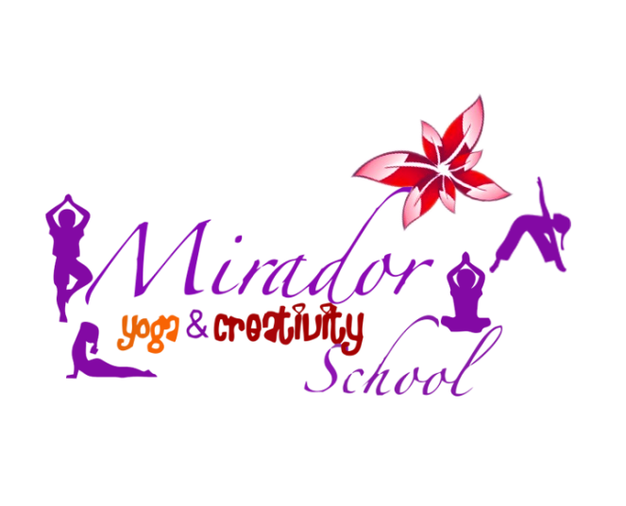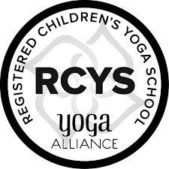
Become a Children’s Yoga Teacher by taking this Accredited Program with Yoga Alliance
The Mirador Kids Yoga Teacher Training (our 95 Hour Certification Program Accredited through Yoga Alliance) equips you with yoga methodology, keen awareness, creativity coaching tools, confidence, and all the playful energy you need to create the most impact in your work with children as you reinvent new facets of educational leadership.​ Please note that this program stands alone as a Specialization for Teaching kids yoga for all those who have not taken 200 hour Yoga Teacher Training and you can start teaching kids yoga classes right after graduation (If you are already a RYT 200 - a registered adult yoga teacher with Yoga Alliance, you can add the new designation of RCYT - registered children's yoga teacher -with this training (a couple of steps are required to do so: submitting our certificate of completion and entering 30 practice kids yoga teaching hours into the Yoga Alliance web database). Our training combines 10 modules of independent/online learning with 10 LIVE modules of face to face instruction. Every one of the TEN Modules counts towards CEUs for yoga teachers (RYTs) who need continuing education units every three years as well as towards your 95 hour Children's Yoga Specialty with Yoga Alliance. This training also counts towards CEUs & professional development hours for educators (please check with Cezarina and also your local PD person). If this journey is for you:
- Visit www.cezarinatrone.com or call 513-432-4887 for details (as you will first need to download a registration form to submit. This is a SEVEN teacher group training (no more than seven teachers take the journey together with trainer) and it is first come and first served to maintain the quality of this multilayered journey.)
- There are 10 Modules of Study face to face (see info below with their specific topics)
- Regular Price Option is: Pay per Module ($150 per module or pay Full Discounted Tuition of $1355 saving $150 off the total price.) We will meet at Cincinnati Yoga School on the specified Saturdays and Sundays above (see dates) from 12:30 PM to 7 PM. Each module has a checklist with step by step instructions).
- If you prefer to pay in full now for the entire training, use our special discount that is applied; so instead of paying $1500 (ten modules’ price at $150 for each module, you will be paying only $1355 (this payment can be made with check/cash/money order or online using Paypal on our Online Store link).
- HOW LONG: Training will start on Sat, September 24th-November20th (if you are missing a module, please discuss with Cezarina optional make up days for the future). Graduation will be scheduled for you as soon as needed.
- Hands on training happens for TEN chosen Saturdays and Sundays from 12:30 PM to 7 PM and the independent /online hours are done on your own and also collaborating with the trainer (you will receive a special password to access online learning modules).
Module 1 & 9: Multilayered MIRADOR Curriculum: Yoga-Based Quantum Creative Practices & Themed Sequences
Module 2 & 8: Journeys into the New Consciousness of Education: Exploring the MIRADOR Yoga & Creativity Toolbox
Module 3: The Anatomy of A Universal Being: Growing & Glowing Strong Together
Module 4: Awake within Your Life: Spinning the Mirador Lotus Flower
Module 5: Your Practicum: Living Yoga: Embodiment at Its Best
Module 6 & 10: Understanding the New Children: Children’s Yoga & Quantum Creativity Adventures
Module 7: Play & Creativity Coaching: Create Your Life of Wonder, Pure Magic, Ease & Flow
What makes this training UNIQUE besides coaching and inspiring you to teach
kids yoga and nurturing your own inner child?
- Innovative Yoga and Mindfulness Practices for day to day use
- Life Coaching Foundation Skills (these are very much needed in learning to assist children and honor where they are at in their own life journey now; these are also powerful coaching tools, plus a pdf or a paperback copy of the book IMAGICA by Santari Green, plus conference calls with Santari himself, creator of magical reality and amazing Life Coach from UK. )
- Neuroscience Learning Templates to help sustain your own yoga teaching journey as you evolve your work in the world.
- Out of the box creativity coaching tools so you can now fully embrace your own magnificence.
- Magical music playlists and guided meditations as well as Storytelling Flow boards
- Other Practical Tools to bring kids yoga to life everywhere you go
- A community of like-minded Beings…and so much more...
Want More Info about Curriculum? Visit website www.cezarinatrone.com or Call 513-432-4887

