95 Hour - CHILDREN’S YOGA & Mindfulness Teacher Training- Fully Accredited through Yoga Alliance ~ FALL Intensive 2019 in Cincinnati, OH ~ www.miradorkidsyoga.com ~Email: miradorintl2018@gmail.com ~513-432-4887~
WHERE: True Freedom Yoga Studio (1926 Mills Ave, Norwood/Cincinnati, OH)
TRAINING DATES: Sept 13, 14, 15, 20, 21, 22nd (LEVEL 1)
Oct 25, 26, 27th & Nov. 1, 2, 3rd (LEVEL 2)

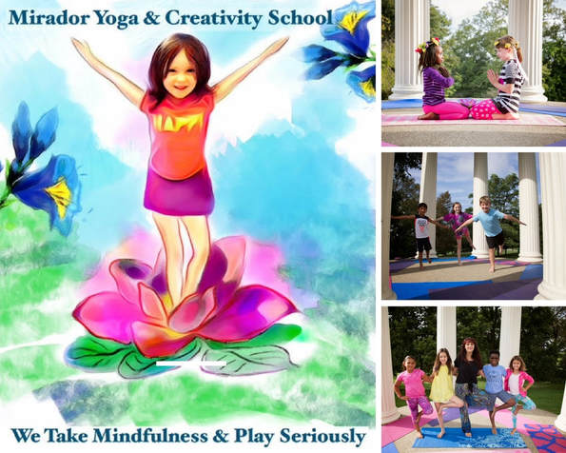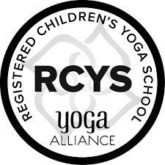

Become a Children’s Yoga & Mindfulness Teacher & An Awesome Creativity Coach by Enrolling in this Fully Accredited MIRADOR Program with Yoga Alliance USA
The Mirador Kids Yoga Teacher Training (our 95 Hour Certification Program Accredited through Yoga Alliance) equips you with yoga methodology, keen awareness, creativity coaching tools, confidence, and all the playful energy you need to create the most impact in your work with children as you reinvent new facets of educational leadership.​ Please note that this program stands alone as a Specialization for Teaching kids yoga for all those who have not taken 200 hour Yoga Teacher Training and you can start teaching kids yoga classes right after graduation (If you are already a RYT 200 - a registered adult yoga teacher with Yoga Alliance, you can add the new designation of RCYT - registered children's yoga teacher -with this training (a couple of steps are required to do so: submitting our certificate of completion and entering 30 practice kids yoga teaching hours into the Yoga Alliance web database). Our training combines 10 modules of independent/online learning with 10 LIVE modules of face to face instruction. Every one of the TEN Modules counts towards CEUs for yoga teachers (RYTs) who need continuing education units every three years as well as towards your 95 hour Children's Yoga Specialty with Yoga Alliance. This training also counts towards CEUs & professional development hours for educators (please check with Cezarina and also your local PD person). If this journey is for you:
- Visit www.miradorkidsyoga.com or email miradorintl2018@gmail.com call 513-432-4887 for details (as you will first need to download a registration form to submit. Space is limited in this group training in Cincinnati and it is first come and first served to maintain the quality of this multilayered training journey.
- There are 10 Modules of Study face to face (see info below with their specific topics)
- Regular Price Option is: Pay per Weekend ($425 per 25 hours of instruction or pay per Level One or Level Two (845$ each) or Pay Full Discounted Tuition of $1650 saving $200 off the regular training price of $1850.)
- We will meet at True Freedom Yoga Studio on the specified Friday Evenings (6-9PM) and on Saturdays and Sundays above (see dates) from 9 AM to 7 PM. Each module has a checklist with step by step instructions).
- HOW LONG: Training will start with LEVEL ONE on Fri evening Sept 13th and continue on Sat, Sept 14th and Sun Sept 15th followed by Fri evening Sept 20th and Sat and Sun (Sept 21-22nd). LEVEL TWO takes place during the two weekends of Oct 25-26-27th and Nov 1-2-3rd, 2019). Certification with Yoga Alliance is obtained after Level 1 and 2 are completed (please contact the trainer for details). Graduation will be scheduled for you as soon as needed.
- On first day of training, each Mirador training participant will be given immediate online access to the Online Mirador Modules (you will receive a special password with lifetime access 10 Unique online learning modules).
Module 1 & 9: Multilayered MIRADOR Curriculum: Yoga-Based Quantum Creative Practices & Themed Sequences (includes Special Needs & Trauma Sensitive kids)
Module 2 & 8: Journeys into the New Consciousness of Education: Exploring the MIRADOR Yoga & Creativity Toolbox
Module 3: The Anatomy of A Universal Being: Growing & Glowing Strong Together
Module 4: Awake within Your Life: Spinning the Mirador Lotus Flower
Module 5: Your Practicum: Living Yoga: Embodiment at Its Best
Module 6 & 10: Understanding the New Children: Children’s Yoga & Quantum Creativity Adventures
Module 7: Play & Creativity Coaching: Create Your Life of Wonder, Pure Magic, Ease & Flow

What makes this training UNIQUE besides coaching and inspiring you to teach kids yoga & mindfulness and nurturing your own inner child?

- Innovative Yoga and Mindfulness Practices for day to day use
- Life Coaching Foundation Skills (these are very much needed in learning to assist children and honor where they are at in their own life journey now; these are also powerful coaching tools, plus a pdf copy of the book IMAGICA by Santari Green, plus conference calls with Santari himself, creator of magical reality and amazing Life Coach from UK. )
- Neuroscience Learning Templates to help sustain your own yoga teaching journey as you evolve your work in the world.
- Out of the box creativity coaching tools so you can now fully embrace your own magnificence.
- Magical music playlists and guided meditations as well as Storytelling Flow boards
- Other Practical Tools to bring kids yoga to life everywhere you go
- A community of like-minded Beings…and so much more...
Want More Info about Curriculum? Visit website www.miradorkidsyoga.com and
www.cezarinatrone.com or Call 513-432-4887

