95 Hour - CHILDREN’S YOGA & Mindfulness Teacher Training- Fully Accredited through Yoga Alliance ~ Fall 2019 in Cincinnati, OH ~ 513-432-4887
WHERE: True Freedom Yoga Studio in Norwood/ Cincinnati
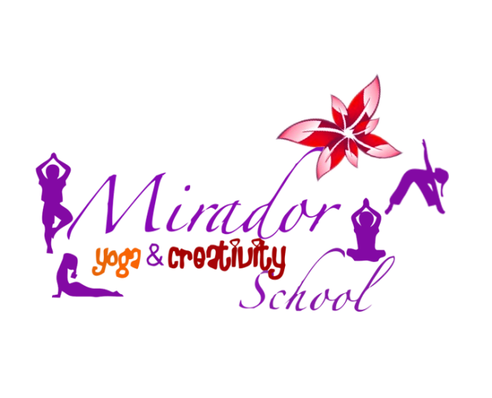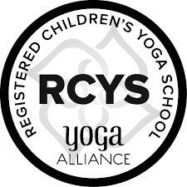
Become a Children’s Yoga Teacher by taking this Accredited Program with Yoga Alliance
The Mirador Kids Yoga Teacher Training (our 95 Hour Certification Program Accredited through Yoga Alliance) equips you with yoga methodology, keen awareness, creativity coaching tools, confidence, and all the playful energy you need to create the most impact in your work with children as you reinvent new facets of educational leadership.​ Please note that this program stands alone as a Specialization for Teaching kids yoga for all those who have not taken 200 hour Yoga Teacher Training and you can start teaching kids yoga classes right after graduation (If you are already a RYT 200 - a registered adult yoga teacher with Yoga Alliance, you can add the new designation of RCYT - registered children's yoga teacher -with this training (a couple of steps are required to do so: submitting our certificate of completion and entering 30 practice kids yoga teaching hours into the Yoga Alliance web database). Our training combines 10 modules of independent/online learning with 10 LIVE modules of face to face instruction. Every one of the TEN Modules counts towards CEUs for yoga teachers (RYTs) who need continuing education units every three years as well as towards your 95 hour Children's Yoga Specialty with Yoga Alliance. This training also counts towards CEUs & professional development hours for educators (please check with Cezarina and also your local PD person).
EXPLORING the MULTI-LAYERED MIRADOR Children’s Yoga Teacher Training Curriculum:
MODULES 1 & 9: Yoga-Based Quantum Creative Practices & Themed Sequences
Objectives:
- Practicing and teaching proper alignment and understanding the power of breath-focused activities
- Giving appropriate cues for yoga sequence transitions and expressing the benefits of various yoga poses (anatomically and therapeutically).
- developing a constant awareness in balancing the many energies, colors and flavors of one’s whole being (use neuro wisdom and life /wellness coaching components)
- honoring child development and their inner wisdom as well
- enhancing one’s own creativity by using themed sequences (such as sun salutations & moon salutation to honor both masculine and feminine aspects of our energy.)
- learning to use a given checklist to include aspects from all seven empowering Mirador Guiding Principles from Cezarina’s Own Mirador Coaching Model & Method (mindfulness with motivation, intention, re-emergence with integration, artistic expression, detachment with compassion, oneness, rebirth with celebration) in the design of each yoga practice.
MODULES 2 & 8: Journeys in the New Consciousness of Education: Using the Mirador Yoga & Creativity Toolbox
Notes: Students will learn what it takes to create an amazing kids yoga session (how to set up the mood and the space as well as inviting children’s creativity to enhance the whole experience, clear communication verbal and/or nonverbal, time management skills, etc.) through class discussions and an overview.
Objectives:
- Determine priorities within a yoga setting and class plan (inclusion, adaptations for special needs, modifications according to the energetic tone of the session, using teacher’s intuition to read the room and the group, using special props, scents, lightning, music, meeting the moment as it emerges…etc.)
- Exploring themed yoga lesson plans & then creating one’s own multimedia yoga lessons
- Learning how to sequence yoga poses and fun games (stories, songs, activities) to enhance the learning process
- Learning to meet children where they are, as well as being with your own inner magical child
- Practicing ‘just in time’ communication & creativity coaching skills
- Building self-confidence as a teacher by knowing how to balance nurturing qualities with clear boundaries
- Learning time management and tuning into easy flow
- Self-directed learning journeys put into practice to change the world
- Learning kids yoga through stories, play, dance, art, poetry…
Module 3: The Anatomy of a Universal Being (Growing & Glowing Strong Together)
Objectives:
- Learning how the science of yoga relates to the growing bodies of boys and girls (benefits, contraindications, healthy movement patterns, etc)
- Understanding stages of childhood development from ages 2-15 (including special needs)
- Explaining alignment of yoga postures along with their anatomical point of focus for benefits or contraindications
- Exploring the seven chakras by using specific yoga poses, guided meditations, and the Mirador Chakra Map
- Sound vibrational work
Module 4: Awake within Your Life (Spinning the Mirador Lotus Flower)
Using the Mirador given content, online research, videos, research, specific sacred texts, as well as their own written reflections and multimedia creations, students will study and integrate the yoga philosophy of being awake within their life now.
Objectives:
- Understanding the ethical aspects of teaching kids yoga and being aware of common challenges faced by kids yoga teachers
- Appreciating the ancient roots of yoga (yamas & niyamas) and learning to translate their benefits within a daily yoga practice for kids growing up in a modern world in the age of speed
- Eight limbs of yoga, the Mirador Coaching Model (and its 7 guiding life principles)
- Learning to clarify yoga expectations, intentions and goals for each session
- Learning about different schools of yoga, mindfulness and meditation and writing/creating personal reflections/presentations about one’s own integrated teaching style and how it applies to the needs of kids today
- Using the Neuro Science given principles and templates
- Identifying relevant themes in a child’s life and using yoga philosophy to provide creative solutions for any present challenges (death of grandparent or pet, parents’ divorce, moving to a different school, bullying, etc)
- Empowering oneself to make time each day and be still, trusting one’s intuitive power.
Module 5: Living Yoga ~ Embodiment at Its Best
Objectives:
- Students will practice teaching and observing their peers practice teach several kids yoga and mindfulness sessions.
- Students will be observing and giving feedback to others during the practicum
- Students will get a deeper understanding of right sequencing, room and props’ set up, tone of voice, holding a clear intentional energetic and yet nurturing space for others, as well as what new possibilities might present themselves in a kids yoga session.
Modules 6 & 10: Understanding the New Children
Students will:
- deepen their teaching skills by immersing themselves in the creation of fun themed kids yoga classes
- students will study and understand all childhood developmental stages, (physical, emotional, cognitive and behavioral for ages 2-15) through reading, watching online videos and lectures
- students will receive a good understanding of their connecting role and that of enhancing relationships as a yoga teacher who thrives on clear communication with parents, guardians and any other adults involved in his/her yoga kids’ lives.
- Students will practice life coaching skills
- students will also observe each age group (2-4, 5-8 and 9-15) for a minimum of 3 hours in a chosen educational setting, take notes and then create appropriate one yoga sequence for each of these age groups, culminating with their return to one of the three chosen educational settings (classroom, child center, etc) to teach a minimum of 30 minute themed kids yoga session and then having the classroom teacher fill out a feedback form to evaluate their performance.
- students will later write their own essay with personal reflections of what they learned from teaching their kids yoga session ( how their observing time helped them understand the appropriate yoga approach for the specific children’s developmental stages, how they perceived their role as a yoga teacher, further insights about their communication style and enhancing relationships with other adults involved in these children’s lives, like parents or other teachers)
Module 7: Intricacies of the Whole Journey as a Teacher & Inner Guide to Self and Others
- Exploring more resources for kids yoga & creativity coaching life lessons
- Deeper look at self-love & mindfulness themes emerging
- The business aspects of working with kids yoga and mindfulness in different settings
- Discussions about all special kids and especially autistic children
- Playfulness & Creativity Coaching Skills (How to Create A Life of wonder, Pure Magic, Ease & Flow)
4 Weekend Format: 2 weekends in SEPT 2019 & 1 Weekend in Oct and 1 Weekend in Nov
DISCOUNTED Tuition:$1650
SAVE $200 from regular priced Tuition of $1850 ($425 per full weekend training). Payment arrangements can be made if you choose Level 1 or Level 2. A $150 deposit is required to register. All Full training participants who graduate will receive a 95 Hr Children’s Yoga Teacher Training Certificate fully accredited through Yoga Alliance and they will be able to teach kids yoga and mindfulness classes right away. Completion of this training also allows a RYT-200 to register with Yoga Alliance as RCYT.

