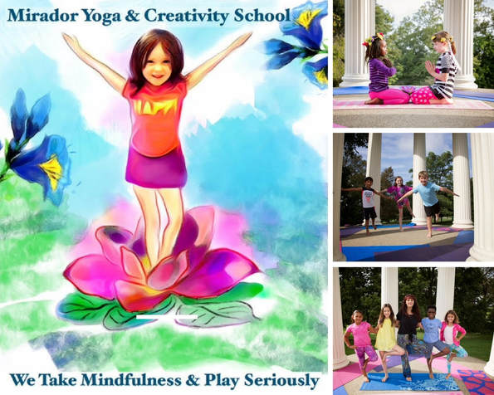
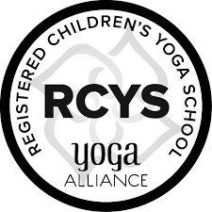
Registration & Liability Waiver:
Specialized 95 Hour Mirador Kids Yoga Teacher Training Program (Registered with Yoga Alliance)

Date ___________ Full Name ___________________________________________________________
Mailing Address _______________________________________________________________________
Email: _____________________________________ Cell Phone/Home Phone _____________________
Occupation __________________________________Date of Birth______________________________
My primary intentions for taking this training ______________________________________________
__________________________________________________________________________________________________________________________________________________________________________
__________________________________________________________________________________________________________________________________________________________________________
_____________________________________________________________________________________
_____________________________________________________________________________________
List any health issues ___________________________________________________________________
I, _______________________waive and release Mirador Yoga & Creativity School (Cezarina Trone) from any claim, demand, cause and action of any kind resulting from or related to my participation in this program. I certify that my level of physical condition as determined by myself or my physician will allow me to safely participate in this program. I understand that completion of this course is in recognition of training rather than a statement of certification. I understand that I will receive a certificate of completion of this Specialized 95 Hour Training which allows me to teach children’s yoga right away.

I have read the email provided by Cezarina from Yoga Alliance addressing the differences between teaching kids yoga with this 95 hour training graduation certificate versus teaching kids yoga as a registered yoga teacher with Yoga Alliance (which requires extra steps to follow). I understand that not all yoga studios are alike and some may want registered yoga teachers for kids’ classes. If I desire to teach at a specific yoga studio, it is my responsibility to contact that studio and confirm that they accept my Specialized 95 Hour Kids Yoga Teacher Training Certificate Approved by Yoga Alliance.
I understand that it is entirely appropriate for Mirador Yoga & Creativity School to be listed in my bio course or resume as a statement of my specialty children’s yoga training.
I understand that payment (full tuition of ______or pay per level price of ______) for this training is non-refundable, but it transfers to future training dates (if I need to make up a small portion of the full training within 6-12 months since I began the course). I agree that I am responsible to make up arrangements for my makeup days. I can wait until another module comes back around or pay for a private module session with my trainer (a special fee applies here) if I cannot wait that long.
I have read the above release and waiver of liability and I fully understand its content. I am legally competent to sign and voluntarily agree to the terms and conditions stated above.

Print name _______________________________________________________________________
Signature ________________________________________________________________________
Date Signed ________________________________________________________________________

